**Matthew Hardenburg – GAME 420 Minor Project Write-Up**

For this minor project, I sought out to reimagine a more streamlined version of my DnD group’s first campaign through Twine. I had never used Twine before, but Harlowe was fairly easy to pick up. The game plays through the eyes of our warlock, but the events are not canon.

In the original campaign, the gang explored a huge mansion to find the seven letters of the command word across three sessions. However, due to their shenanigans, multiple casualties ensued. The gnome wizard, Boddynock, died trying to solo the “Chained Library” boss, Gorrador the dragonborn paladin died after missing 6 attacks in a row against a solitary “Flying Sword”. I didn’t want to kill their characters in the first campaign, therefore: Boddynock’s unconscious body ended up being chained to a bookshelf in another part of the house, and Gorrador was transformed into a frog down in the basement laboratory. Gorrador could of course be turned back into his old self with a conveniently placed potion, which they immediately spilled half of. By time they left the house, they had a new lease on life, and Gorrador was sporting a fresh pair of frog legs.

During the game’s development, the largest issue I ran into was properly utilizing Harlowe. During one point, I had a misplaced bracket in a triple nested if/else clause, and combat would draw out indefinitely, never reaching the Boolean assignment at the end to move on. My sparse knowledge of HTML/CSS also allowed me to nicely customize various elements, such as the combat interface.

However, the game is naturally not perfect. This is primarily due to the fact that I was learning Harlowe as I created the game. If I had more time to continue work on it, there are a few issues I would like to fix. As noted by my playtesters, the infinite use heal in combat is overpowered, but this problem was somewhat fixed by the implementation of a two turn cooldown. I would have liked to implement an entire inventory system with its own interface just to accommodate healing items, but time constraints did not allow for this. I also would have liked to flesh out the combat a bit more, with more spell variety and potentially movement for both the player and the enemy. If I do choose to do another Twine game for the major project, these are definitely elements I will be considering.

Overall, I’m pretty satisfied with how the game turned out. I set out to create a short retelling of the journey through the mansion, and I now have a playable text adventure game. Through playtesting with the DnD group, it is virtually bug-free (as far as I can tell) and runs without a problem. While the game is fairly barebones, I am content with its quality as my first Twine game.

**PLAYTESTER FEEDBACK:**

They playtesters were members of my discord server for the DnD group. Some of them procrastinated however, so not everyone got to play it before the final submission.

Boddynock here played the first release, 0.5, and brought numerous typos to my attention.

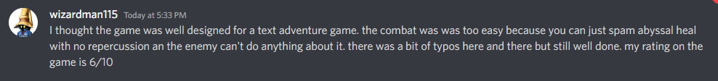

Our druid also played 0.5.

Our ranger played the updated version, 0.6, with a nerf to Abyssal Heal. He also helped in the editing process, pointing out run-on sentences and various places where the flow was disrupted.

Boddynock’s updated review after I implemented a two-turn cooldown on Abyssal Heal in 0.7



For the final submission, 1.0 release, I finalized balancing (hopefully) for enemy encounters based on their verbal feedback.